Downloading...
From: https://drive.google.com/uc?id=1VJaDVtDUtKQMmhRAqr3t-fgng899ZdRV
To: /content/Python Application Usage Log Data Set.xlsx
100%|██████████| 1.68M/1.68M [00:00<00:00, 105MB/s]
/usr/local/lib/python3.12/dist-packages/statsmodels/stats/outliers_influence.py:197: RuntimeWarning: divide by zero encountered in scalar divide
vif = 1. / (1. - r_squared_i)
[VIF] Dropped 'is_weekend' (VIF=inf). Remaining cols: 46
ADF Statistic: -9.6707, p-value: 0.0000
Any object dtypes in X? -> False
Remaining NaNs in X? -> 0
X columns used: 46
Checked order (0, 1, 0), AIC=68371.38, LB p10=0.000, p20=0.000
Checked order (0, 1, 1), AIC=67231.20, LB p10=0.000, p20=0.000
Checked order (0, 1, 2), AIC=67145.11, LB p10=0.000, p20=0.000
Checked order (0, 1, 3), AIC=67116.33, LB p10=0.000, p20=0.000
Checked order (1, 1, 0), AIC=67694.53, LB p10=0.000, p20=0.000
Checked order (1, 1, 1), AIC=67128.75, LB p10=0.000, p20=0.000
Checked order (1, 1, 2), AIC=67104.51, LB p10=0.000, p20=0.000
Checked order (1, 1, 3), AIC=67079.27, LB p10=0.000, p20=0.000
Checked order (2, 1, 0), AIC=67390.63, LB p10=0.000, p20=0.000
Checked order (2, 1, 1), AIC=67099.60, LB p10=0.000, p20=0.000
Checked order (2, 1, 2), AIC=67101.11, LB p10=0.000, p20=0.000
Checked order (2, 1, 3), AIC=67044.33, LB p10=0.000, p20=0.000
Checked order (3, 1, 0), AIC=67324.06, LB p10=0.000, p20=0.000
Checked order (3, 1, 1), AIC=67047.09, LB p10=0.000, p20=0.000
Checked order (3, 1, 2), AIC=67094.21, LB p10=0.000, p20=0.000
Checked order (3, 1, 3), AIC=67078.40, LB p10=0.000, p20=0.000

Selected order by AIC (no model fully passed Ljung–Box): (2, 1, 3), AIC=67044.33

SARIMAX Results
==============================================================================
Dep. Variable: daily_active_users No. Observations: 4631
Model: SARIMAX(2, 1, 3) Log Likelihood -33470.167
Date: Wed, 15 Oct 2025 AIC 67044.334
Time: 08:00:01 BIC 67379.186
Sample: 08-01-2012 HQIC 67162.158
- 04-05-2025
Covariance Type: oim
===============================================================================================
coef std err z P>|z| [0.025 0.975]
-----------------------------------------------------------------------------------------------
session_count 1014.1542 8.389 120.895 0.000 997.713 1030.596
avg_session_duration 15.8810 16.598 0.957 0.339 -16.651 48.413
like_count 9.2072 15.308 0.601 0.548 -20.796 39.210
share_count 7.3796 13.307 0.555 0.579 -18.702 33.461
download_count -11.2907 16.078 -0.702 0.483 -42.804 20.223
comment_count -11.4160 15.420 -0.740 0.459 -41.638 18.806
error_count 9.9856 6.449 1.549 0.122 -2.653 22.624
release_flag -1.5648 4.486 -0.349 0.727 -10.356 7.227
app_Business Courses app 1.5008 6.202 0.242 0.809 -10.654 13.656
app_Facebook 3.9115 11.270 0.347 0.729 -18.178 26.001
app_Health Courses app -3.4755 5.506 -0.631 0.528 -14.267 7.316
app_Instagram 1.0682 9.967 0.107 0.915 -18.467 20.603
app_LinkedIn 6.7849 7.240 0.937 0.349 -7.405 20.975
app_Online Course app -5.2135 60.086 -0.087 0.931 -122.980 112.552
app_Pinterest -1.7092 6.730 -0.254 0.800 -14.901 11.482
app_Programming Courses app 0.3888 4.695 0.083 0.934 -8.814 9.591
app_Quora 5.4834 6.530 0.840 0.401 -7.314 18.281
app_Quora Website 0.6752 4.754 0.142 0.887 -8.642 9.992
app_Reddit 2.2745 6.994 0.325 0.745 -11.434 15.983
app_Science Courses app 6.2414 4.537 1.376 0.169 -2.652 15.135
app_Snapchat 9.5793 6.162 1.555 0.120 -2.497 21.656
app_Telegram 10.7855 5.736 1.880 0.060 -0.456 22.027
app_Threads -2.7534 5.281 -0.521 0.602 -13.105 7.598
app_TikTok 2.4155 7.132 0.339 0.735 -11.564 16.394
app_Twitter 5.2246 7.019 0.744 0.457 -8.533 18.982
app_WeChat 8.0760 5.058 1.597 0.110 -1.838 17.990
app_WhatsApp 11.8479 4.885 2.425 0.015 2.273 21.423
app_X (formerly Twitter) 15.2728 5.062 3.017 0.003 5.352 25.194
app_YouTube 1.8269 6.007 0.304 0.761 -9.947 13.601
dow_1.0 -1.3165 5.255 -0.251 0.802 -11.616 8.983
dow_2.0 -12.9578 5.766 -2.247 0.025 -24.259 -1.656
dow_3.0 -6.2351 5.818 -1.072 0.284 -17.639 5.168
dow_4.0 -4.6101 5.815 -0.793 0.428 -16.008 6.788
dow_5.0 -15.9596 5.766 -2.768 0.006 -27.261 -4.658
dow_6.0 -5.7282 5.251 -1.091 0.275 -16.020 4.564
mon_2.0 11.1777 14.721 0.759 0.448 -17.675 40.031
mon_3.0 -8.2222 15.219 -0.540 0.589 -38.051 21.607
mon_4.0 -20.8209 16.213 -1.284 0.199 -52.597 10.956
mon_5.0 -16.8654 16.423 -1.027 0.304 -49.054 15.323
mon_6.0 14.2065 15.205 0.934 0.350 -15.594 44.007
mon_7.0 42.4480 15.655 2.711 0.007 11.765 73.131
mon_8.0 15.9213 16.537 0.963 0.336 -16.490 48.333
mon_9.0 7.4648 16.362 0.456 0.648 -24.604 39.534
mon_10.0 1.8571 15.673 0.118 0.906 -28.861 32.575
mon_11.0 -8.9686 15.005 -0.598 0.550 -38.377 20.440
mon_12.0 22.5615 14.171 1.592 0.111 -5.212 50.335
ar.L1 0.4386 0.219 2.000 0.045 0.009 0.868
ar.L2 0.3662 0.181 2.024 0.043 0.012 0.721
ma.L1 -1.0436 0.215 -4.845 0.000 -1.466 -0.621
ma.L2 -0.2322 0.309 -0.752 0.452 -0.838 0.373
ma.L3 0.2592 0.092 2.802 0.005 0.078 0.440
sigma2 1.057e+05 2429.648 43.507 0.000 1.01e+05 1.1e+05
===================================================================================
Ljung-Box (L1) (Q): 0.00 Jarque-Bera (JB): 690570.16
Prob(Q): 0.95 Prob(JB): 0.00
Heteroskedasticity (H): 0.16 Skew: -0.27
Prob(H) (two-sided): 0.00 Kurtosis: 62.85
===================================================================================

Warnings:
[1] Covariance matrix calculated using the observed information matrix (complex-step) described in Harvey (1989).
Test MAE: 234.935
Test RMSE: 331.082
Test MAPE: 12.87%
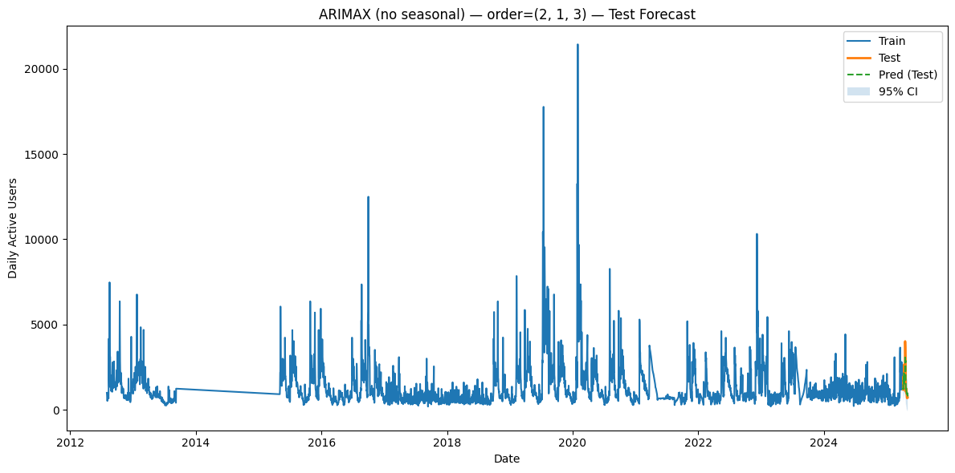

--------------------------------------------------------------------------------

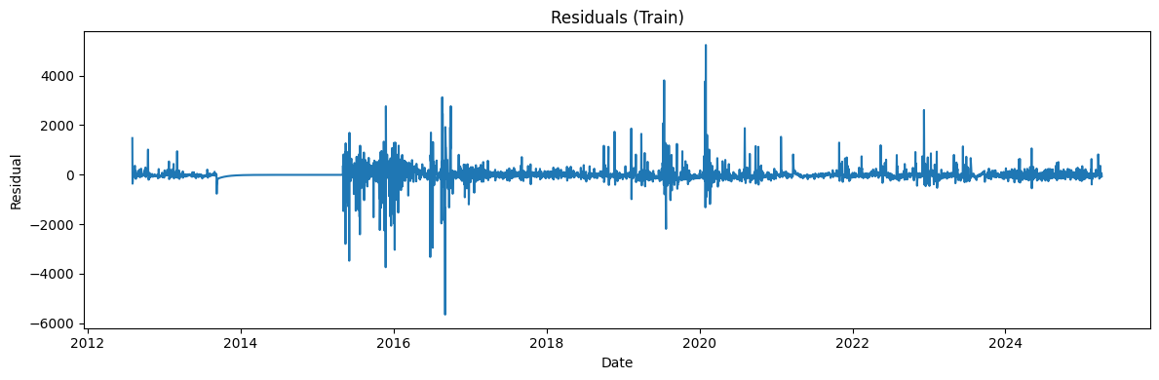

--------------------------------------------------------------------------------

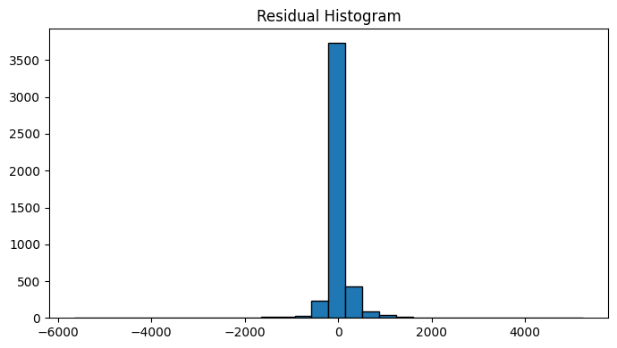
Ljung-Box stats & p-values (train):
lb_stat lb_pvalue
10 32.956525 2.770060e-04
20 99.420471 1.599141e-12

--------------------------------------------------------------------------------

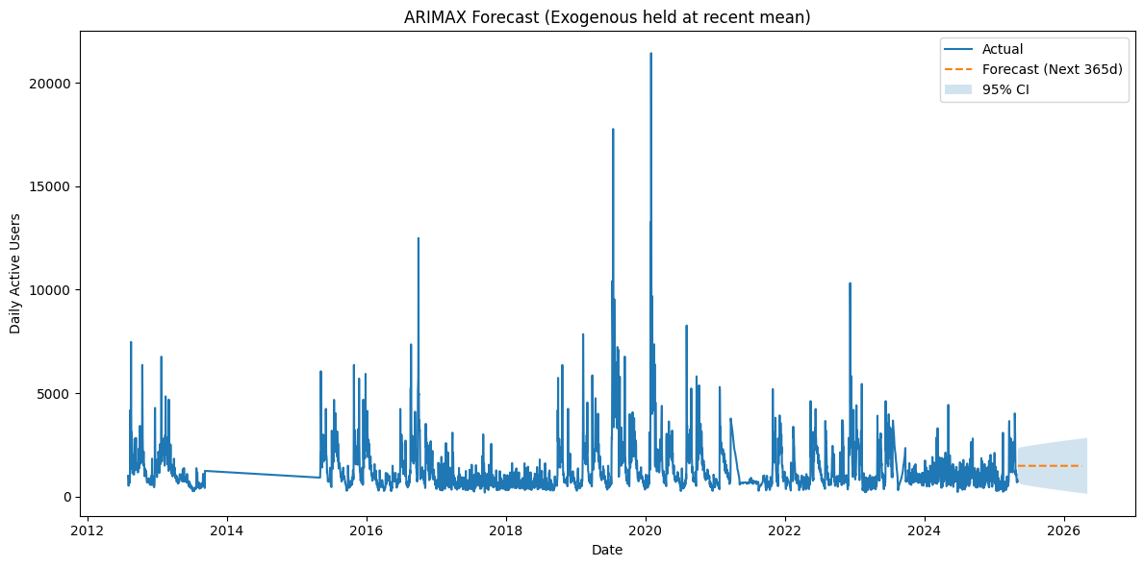

Classification (threshold = train median = 976.093)
Accuracy: 100.00%
F1 Score: 1.000
Precision: 1.000
Recall: 1.000

